**On notebook paper and using the online book, read and answer the following questions.**

**(Diversity of Life pages 90-99)**

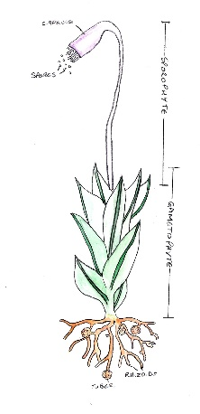

1. Label the following picture parts

2. (Fill in A-E)

|  |  |  |
| --- | --- | --- |
| **Plant** | **Identifiable physical characteristics** | **Where Found** |
| **Mosses** | A | Shady spots, rocks, tree trunks |
| **Liverworts** | B | D |
| **Hornworts** | C | E. |

3. Why are most nonvascular plants short?

4. ____________ anchor moss and absorb water and nutrients.

5. Why do florists recommend not putting plants like ferns in south or west facing windows?

6. In plants, water moves through ____________. Food moves through ______________.

7. Why is club moss not a true moss?

8. **Page 97-** Which group of gymnosperms has the most species?____________________  
 What could have happened to the ecosystem the Ginkgo biloba tree lived in if the tree had become extinct? _______________________________________________________________________

9. What are pollen?

10. Why do you think angiosperms enclose their seeds in fruits?

11. **Vocabulary: Pollen Frond Rhizoid Cotyledon**

A. _____________ A Thin, rodlike structure that anchors a moss plant and absorbs water and nutrients.

B. _____________ A seed leaf

C. _____________ The leaf of a fern

D. ____________ Structures that contain cells that will later become sperm cells