**CRUSTACEAN**crayfish, crabs

<http://news.neaq.org/2012/10/new-lobster-dressed-for-halloween.html>

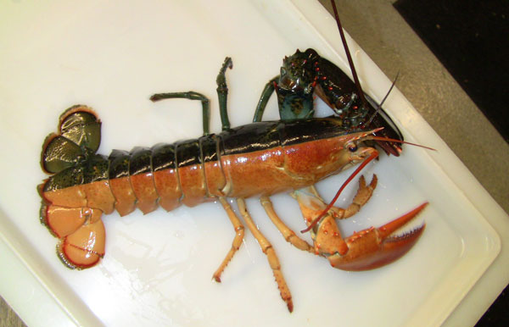

Lobster scientists theorize that the bizarre duality of splits is caused by a complete cellular split when the lobster egg is first fertilized. Splits are often hermaphrodites showing sexual characteristics of both genders. However, this lobster is a female.    Split lobsters are roughly estimated to occur once in every 50 to 100 million lobsters. In the last ten years, “splits” have been caught in Maine and Rhode Island. This past summer, splits were discovered in both Nova Scotia and Prince Edward Island.

**Crayfish organs and functions  
nervous system**  
1. **Antennae** - long sensory appendages of the head region of the cephalothorax section of a crayfish, for sensing food and   
touch.  
2. **Antennule** - short sensory appendages below the eyestalks of the head region of the cephalothorax section of a crayfish,   
sensing food and touch.  
3. **Eye** - rest atop stalks on the head region of the cephalothorax section of the crayfish, for sensing light.  
4. **Ventral nerve cord** - the nerve cord that connects the brain in the head region to the body.  
5. **Brain** - sends and receives messages

**skeletal system**  
1. **Cheliped** - large walking, grasping, and defensive appendages (first pair) of a crayfish.  
2. **Rostrum** - the protrusion at the head section of the crayfish which protects the forward sensory equipment (eyestalks,   
antennules, antennae).  
3. **Walking legs** - the 4 pairs of appendages used for locomotion in the crayfish.  
4. **Cephalothorax** - the first segment of a crayfish, consisting of a head fused to the thorax.  
5. **Abdomen** - the multi-segmented posterior region of the crayfish used to swim backwards.  
6. **Uropod** - small swimming paddles (2) on the end of the abdomen of a crayfish.  
10. **Telson** - the central swimming paddle of a end of a crayfish abdomen.  
  
**circulatory system**  
12. **Heart** - pumps blood to the body.

**digestive system**  
1. **Stomach** - receives food from the mouth, digests it, and moves it to the intestine.  
2. **digestive gland** - produces digestive enzymes for the stomach for food breakdown.  
3. **Intestine** - absorbs nutrients from the food and passes it to the blood; passes from cephalothorax through the abdomen   
to the telson.  
  
reproductive system  
1. **Gonad** - produces sperm or eggs for reproduction.  
2. ovary  
3. testis  
4. **Swimmeret** - small appendages used for reproduction; in males - used to transfer sperm to females; in females - used to hold eggs and young as they develop.  
  
Muscular system  
1. **Muscle** - used to swim by pulling the abdomen below the cephalothorax.  
  
excretory system  
19. **Green gland** - excretes waste products (nitrogenous) and osmoregulates (balances water) blood.

External [Crayfish dissection video](https://www.youtube.com/watch?v=2cBGuEDxvNo) [External and internal crayfish dissection video](https://www.youtube.com/watch?v=W7F0jZgdc8A)   [Crayfish dissection](http://www.biologyjunction.com/crayfish_dissection.htm)   [Crayfish dissection](https://www.altoona.psu.edu/academics/www/mns/bioal/crayfish/default.htm)