WHAT ARE THE MAJOR GROUPS OF VERTEBRATES?  
    FISH  
    AMPHIBIANS  
    REPTILES   
    BIRDS  
    MAMMALS   
       **FISH -**[**TYPES OF FISH VIDEO**](https://www.youtube.com/watch?v=ZlUpovIkvaA)

The various fish groups account for more than half of vertebrate species. There are almost **28,000** known extant species, of which almost 27,000 are bony fish, with 970 sharks, rays, and chimeras and about 108 hagfish and lampreys. **VERTEBRATE,   
                 LIVES IN WATER ECTOTHERMS, SCALES  
                  OBTAIN OXYGEN THROUGH GILLS**  
            JAWLESS FISH    
                        no scales  
                        no jaws  
                        scrape suck or stab food  
                        skeleton made of cartilage flexible     
hagfish <http://clubtukinews.com/wp-content/uploads/2009/11/hagfish2.JPG>  [hagfish slime video](http://www.discovery.com/tv-shows/other-shows/videos/nasty-by-nature-hag-fish-slime/)

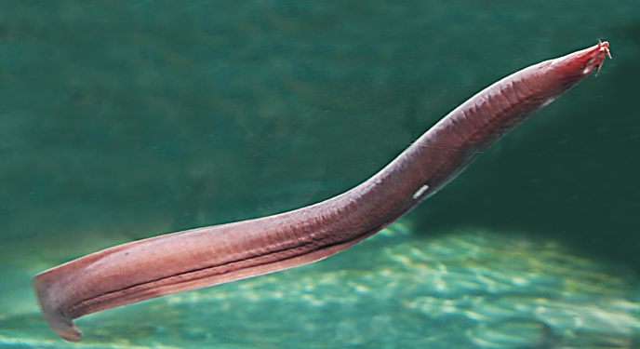 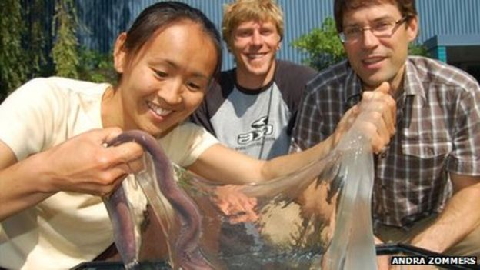

lamprey[http://upload.wikimedia.org/wikipedia/commons/e/e5/Lamprey_illustration_side.png](https://ez002.k12.sd.us/Chapters/Lamprey_illustration_side.png)   <http://www.cnsweb.org/digestvertebrates/Photos/LampreyPacificMouth%20CL04_1c.jpg>    [Lamprey video](https://www.youtube.com/watch?v=9JQ6oHjpeqU)

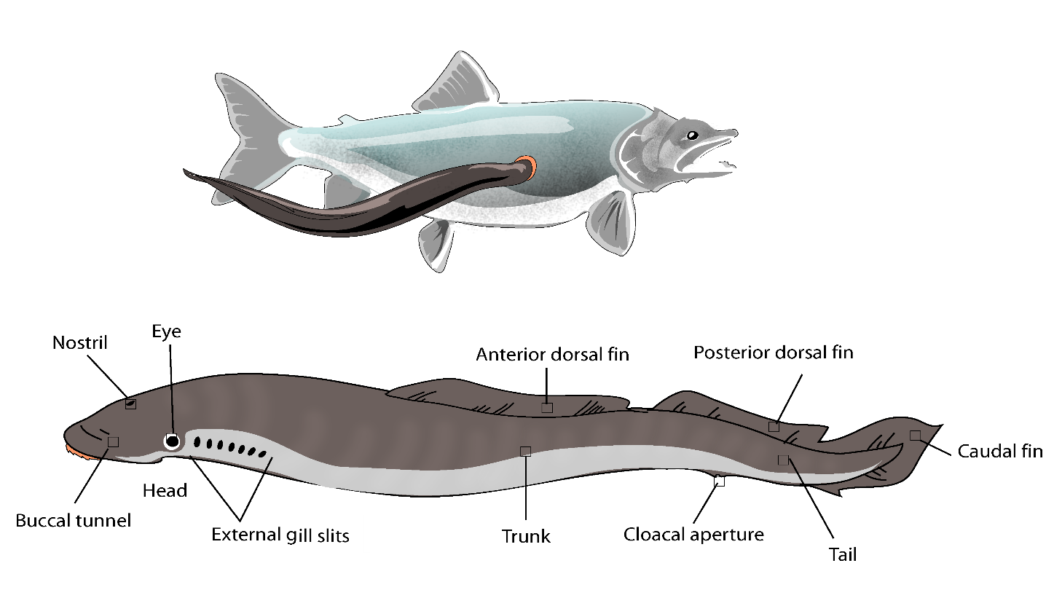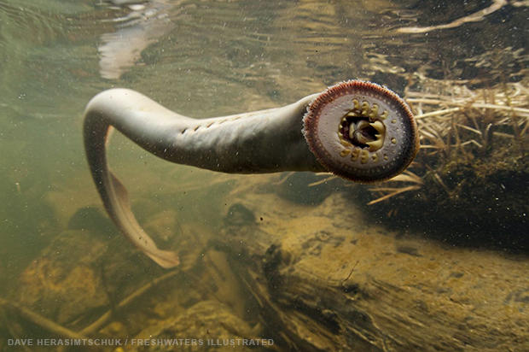  
cartilage fish (caliginous fish)  
        have jaws  
        cartilage skeleton  
shark  http://www.top-adventure-tours.com/image-files/shark-picture.jpg  
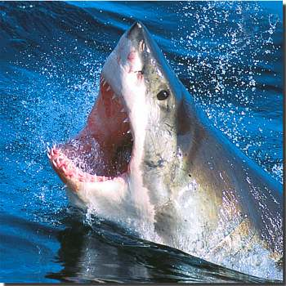 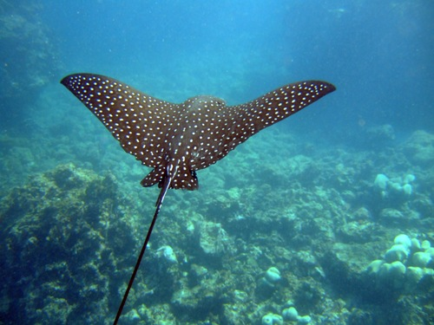

[Ray video](http://www.arkive.org/reef-manta-ray/manta-alfredi/video-00.html)

                BONEY FISH  
                        skeleton is made of hard bone

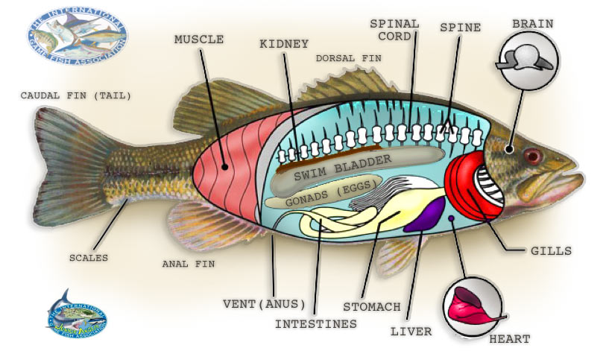  
walleye

[salmon spawning video](https://www.youtube.com/watch?v=SOllUTBYZtE)      [sockeye salmon life cycle](http://www.arkive.org/sockeye-salmon/oncorhynchus-nerka/video-08a.html)     [handfish video](http://www.arkive.org/spotted-handfish/brachionichthys-hirsutus/video-08.html)     
[go to my website for fish dissection](http://dj003.k12.sd.us/science%20labs/dissection/fish%20dissection.htm)  
**circulatory system  
1. HEART - pumps blood  
2. VENTRICLE - pumps blood to body  
3. ATRIUM - pumps blood to ventricle  
  
Excretory system  
1. KIDNEY - filters liquid waste  
  
nervous system  
1. BRAIN - controls body  
2. SPINAL CORD - sends and receives messages  
3. SWIM BLADDER - allows fish to float at any level  
4. LATERAL LINE - senses vibrations and pressure  
5. NOSTRIL - smell  
6. EYE - vision**digestive system  
**1. MOUTH - opening for food  
2. esophagus - forces food from mouth to stomach  
3. STOMACH - breaks down food  
4. GALL BLADDER - stores bile made in liver  
5. bile- breaks down fat  
6. LIVER - makes bile and digestive enzymes detoxes you**7. spleen**- filters out old and dead red blood cells,  dumps them in the intestine.  that is why your poop is reddish brown   6 million per second.  
8. INTESTINE - breaks down and absorbs food  
9. ANUS - opening for wastes  
10. fat - stores food, cushions organs, insulates ( helps keep warm)  
  
reproductive system  
1. GONADS - makes sex cells  
2. ovary - makes eggs  
3. testis - makes sperm**

**respiratory system  
1. GILLS - breathing oxygen and carbon dioxide diffuses here**

**skeletal system  
1. VERTEBRAE - protects spinal cord  
2. SCALES - protect skin  
3. ANTERIOR DORSAL FIN - protection  
4. POSTERIOR DORSAL FIN - protection  
5. PECTORAL FIN - steering and movement  
6. PELVIC FIN - steering and movement  
7. ANAL FIN - steering  
8. CAUDAL FIN - movement  
9. OPERCULUM - protects gills**